INSTITUTO NORTEAMERICANO DE CULTURA

Teacher’s Name: Adriana Felisa Chávez De la Peña

Student’s Name: ______________________________________________________

1. Reading: Read carefully the following story and answer the questions.

Amanda turns on her computer and opens her e-mail. She has a new message. She smiles. It is from Tall_and_Handsome34, a man Amanda met on FindNewLove.com, an online dating website. She really hopes to find a new love, and Tall_and_Handsome34 could be the right man for her! Amanda reads the e-mail. Tall_and_Handsome34 asks Amanda if she would like to meet in person on Friday. He tells her his real name is Mike.

Amanda considers meeting Mike. She only chats with Mike on the computer, but she really likes him. He is smart and funny. They are the same age, share many interests, and live in the same city. She does not know what he looks like, but she enjoys the mystery of a blind date.  
  
Amanda replies to Mike, "Hi Mike. My real name is Amanda." They agree to meet at Amanda's favorite restaurant at 7:30 p.m. on Friday. They plan to meet beside the fountain in front of the restaurant.  
  
On Friday, Amanda prepares for her date. She puts on a dress and curls her hair. She feels nervous and excited!  
  
When Amanda arrives at the restaurant, she sees a tall man by the fountain. She cannot see his face. "That must be Mike," Amanda thinks. She walks toward the man. "Mike?" Amanda asks as the tall man turns around. She sees Mike's face. She is surprised!

"Amanda Jones!" Mike exclaims. He realizes he knows her. Amanda Jones and Mike Miller dated in high school. "I cannot believe it is you!" Amanda and Mike laugh and hug.

"Well," Amanda thinks to herself, "sometimes you can find an old love too!"

**THE END**

* 1. Answer the following questions about the reading:

1. Which do you think would be a good title for the reading?
   1. Titanic 2.0
   2. Online dating
   3. A fake winner
   4. A walk to remember
2. Write true or false.
   1. Amanda is married _____
   2. Mike and Amanda knew each other __________
   3. Amanda’s username was ‘Handsome_and_Tall34’ _________
   4. Mike asked Amanda to meet at the museum _________
3. What does ‘Online Dating’ mean?

____________________________________________________________________________________________________________________________________________________

1. What is the difference between a ‘Dating website’ and a regular social media?

______________________________________________________________________________________________________________________________________________________________________________________________________________________________

1. Do you think Amanda made the right decision on meeting Mike? Justify your answer.

_____________________________________________________________________________________________________________________________________________________________________________________________________________________________

1. Would you recommend a friend to go and try a Dating website? Why?

____________________________________________________________________________________________________________________________________________________

2.- Physical descriptions. Draw the silhouettes below according to the sentences presented.

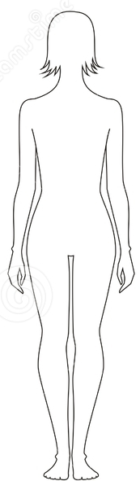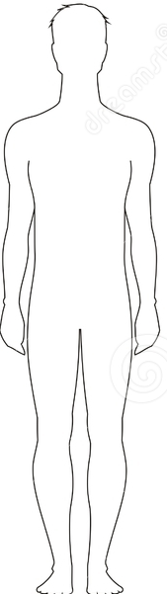

a. His hair is blond b. Her hair is brunette

c. Her jeans are blue d. His shirt is red

e. His eyes are green f. Her shirt is pink

g. Her eyes are brown h. His jeans are black

i. Her shoes are red j. His shoes are white

k. His cap is red l. Her necklace is purple

m. His watch is black n. Her jacket is purple

4.- Write eight sentences to describe the location of some of the objects shown in the picture below.

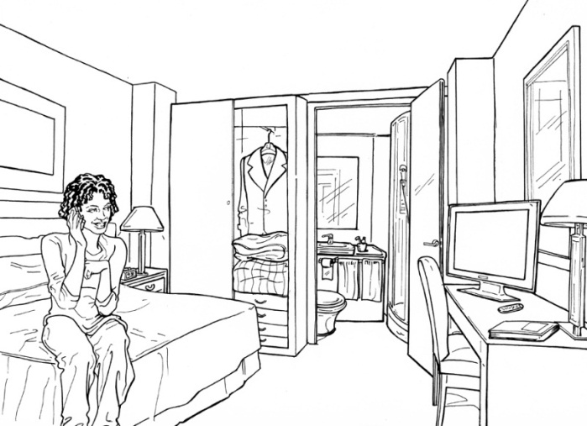a.-_______________________________

b.- _______________________________

c.- _______________________________

d.- _______________________________

e.- _______________________________

f.- _______________________________

g.- _______________________________

h.- _______________________________

5.- Write a number from 1 to 5 for each of the following adverbs of frequency, so that number 5 belongs to the one adverb that indicates the most occurrence.

a. Sometimes __ b. Rarely __ c. Always __ d. Never __ e. Frequently __

6.- Write an example with each of the Frequency adverbs mentioned in exercise 5 (5 sentences total)

a. ______________________________________________________________________________

b. ______________________________________________________________________________

c. ______________________________________________________________________________

d. ______________________________________________________________________________

e. ______________________________________________________________________________

7.- Write a letter to your teacher Adriana, talking about how you felt during 2015 and what are your dreams for 2016. Your letter has to be at least 4 paragraphs long.